**How to delete or remove a MySQL/MariaDB user account on Linux or Unix**

**Posted on**[**February 15, 2017**](https://www.cyberciti.biz/faq/how-to-delete-remove-user-account-in-mysql-mariadb/)**in Categories**[**Linux**](https://www.cyberciti.biz/faq/category/linux/)**,**[**MySQL**](https://www.cyberciti.biz/faq/category/mysql/)**,**[**UNIX**](https://www.cyberciti.biz/faq/category/unix/) last updated February 16, 2017

[https://www.cyberciti.biz/media/new/category/old/mysqllogo.gif](https://www.cyberciti.biz/faq/category/mysql/)

Icreated [a MySQL / MariaDB user account using this page](https://www.cyberciti.biz/faq/mysql-user-creation/). Now, I have deleted my wordpress blog and I want to delete that user account including database too. How do I delete or remove a MySQL or MariaDB user account on Linux or Unix-like system using mysql command line option?  
  
Both MySQL and MariaDB is an open source database management system. In this quick tutorial,**you will learn how to delete ore remove user account in MySQL or MariaDB database on Linux or Unix-like** system.

**Warning**: Backup your database before you type any one of the following command.

**Step 1 – Steps for removing a MySQL/MariaDB user**

If you decided to remove open source application such as WordPress or Drupal you need to remove that user account. You need to remove all permissions/grants, and delete the user from the MySQL table. First, login as mysql root user to the MySQL/MariaDB server using the shell, run:  
$ mysql -u root -p mysql  
OR  
$ mysql -u root -h server-name-here -p mysql  
Sample outputs:

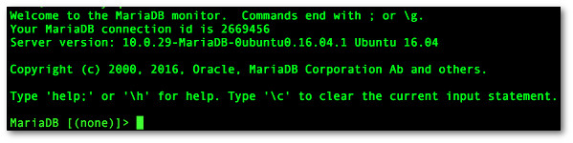Fig.01: The MySQL/MariaDB shell

**Step 2 – List all mysql users**

Once you have a MySQL or MariaDB prompt that looks very similar to fig.01, type the following command at mysql> or mariadb> prompt to see a list of MySQL/MariaDB users:  
mariadb> SELECT User,Host FROM mysql.user;  
Sample outputs:

[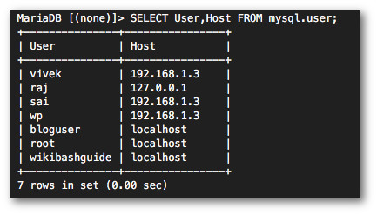](https://www.cyberciti.biz/faq/how-to-show-list-users-in-a-mysql-mariadb-database/)Fig.02: How to see/get a list of MySQL/MariaDB users accounts  
In this above example, I need to delete a mysql user named ‘bloguser’@’localhost’.

**Step 3 – List grants for a mysql user**

To see what grants bloguser have, enter:  
mariadb> SHOW GRANTS FOR 'bloguser'@'localhost';  
Sample outputs:

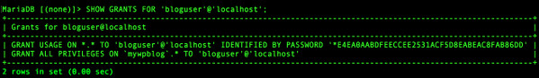Fig.03: Display user grants  
Where,

1. bloguser – Mysql/Maridb user name
2. localhost – Mysql/Mariadb host name
3. mywpblog – Database name

**Step 4 – Revoke all grants for a mysql user**

Type the following sql command:  
mariadb> REVOKE ALL PRIVILEGES, GRANT OPTION FROM 'bloguser'@'localhost';  
Sample outputs:

Query OK, 0 rows affected (0.00 sec)

**Step 5 – Remove/Delete the user from the user table**

Type the following sql command:  
mariadb> DROP USER 'bloguser'@'localhost';  
Sample outputs:

Query OK, 0 rows affected (0.00 sec)

**Step 6 – Delete the database**

Type the following command:  
mariadb> DROP DATABASE mywpblog;  
Sample outputs:

Query OK, 0 rows affected (0.00 sec)

And there you have it. A MySQL/MariaDB user deleted or removed from the server on Unix or Linux via command line option.